
Educational Resource

Wound Management: Jelonet

Sites where the resource can be utilised: All clinical sites were Jelonet is used
Target audience: Clinicians
Purpose: Education related to Jelonet product, application and use guide

Description: Educational information relating to Jelonet

Learning Outcomes: Identify indication/contraindications of Jelonet use
Describe how to apply Jelonet

Keywords: Jelonet, tulle gras, paraffin tulle gras, dressing
Resource registration number
Replaces existing resource? No
Related Legislation, Australian Standard, NSW Ministry of Health Policy Directive or Guideline, National Safety and Quality Health Service Standard (NSQHSS) and/or other, HNE Health Document, Professional Guideline, Code of Practice or Ethics:
NSQHS Standards Criterion and/or other: 1, 3, 8
- NSW Health Policy Directive Clinical Procedure Safety PD 2014_036
http://www0.health.nsw.gov.au/policies/pd/2014/pdf/PD2014_036.pdf
- NSW Ministry of Health Policy PD 2005_406 Consent to Medical Treatment
http://www.health.nsw.gov.au/policies/PD/2005/pdf/PD2005_406.pdf
- NSW Ministry of Health Policy Directive PD 2007_036 Infection Control Policy
http://www.health.nsw.gov.au/policies/pd/2007/pdf/PD2007_036.pdf
- Australian Wound Management Association Standards for Wound Management ST3
http://www.awma.com.au/publications/2011_standards_for_wound_management_v2.pdf
Is this package recorded in HETI? | No
Contact person: Jayne Campbell
Contact details: jayne.campbell@hnehealth.nsw.gov.au

Date accepted by LP committee: N/A
Issue date: August 2015
Review date: August 2018

To view the PowerPoint presentation, double click on the image below and scroll down.
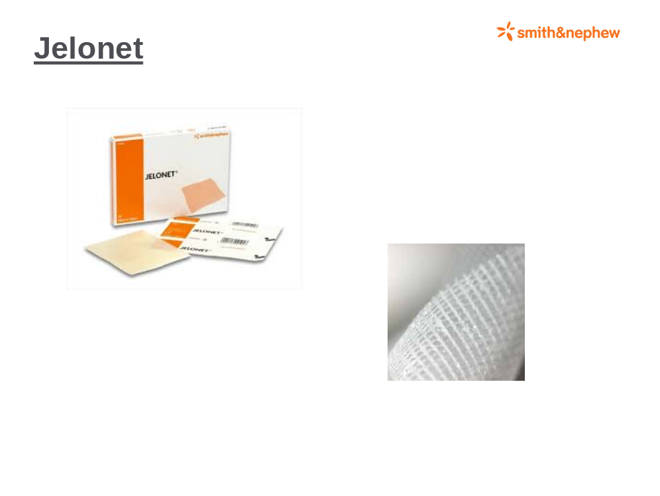

Double click on image above to view presentation.

To print presentation
1. Right click on image, select “presentation object”, and then “open”.
2. The presentation will open in a format that is able to be printed.



